Install Docker and Docker compose on AWS linux ami

Commands used:

**Docker CE Install and start**

sudo amazon-linux-extras install docker

sudo service docker start

sudo usermod -a -G docker ec2-user

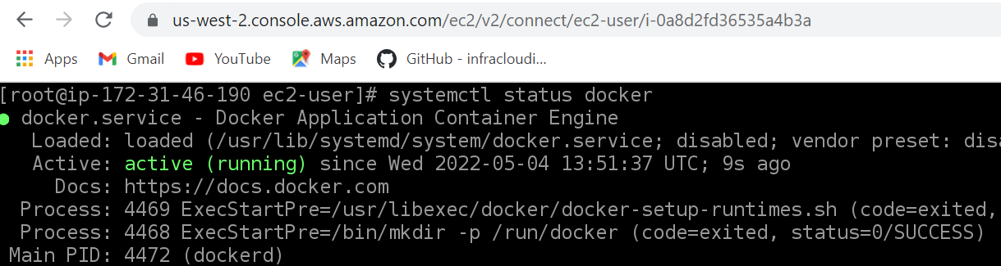

## docker-compose install

Copy the appropriate docker-compose binary from GitHub:

sudo curl -L https://github.com/docker/compose/releases/download/1.22.0/docker-compose-$(uname -s)-$(uname -m) -o /usr/local/bin/docker-compose

sudo curl -L https://github.com/docker/compose/releases/latest/download/docker-compose-$(uname -s)-$(uname -m) -o /usr/local/bin/docker-compose

Fix permissions after download:

sudo chmod +x /usr/local/bin/docker-compose

Verify success:

docker-compose version

**Part 1**

1. Run the container image infracloudio/csvserver:latest in background and check if it's running.

Command: docker run -itd infracloudio/csvserver:latest

1. If it's failing then try to find the reason, once you find the reason, move to the next step.



Write a bash script gencsv.sh to generate a file named inputFile whose content looks like

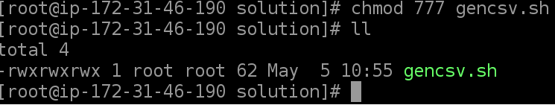

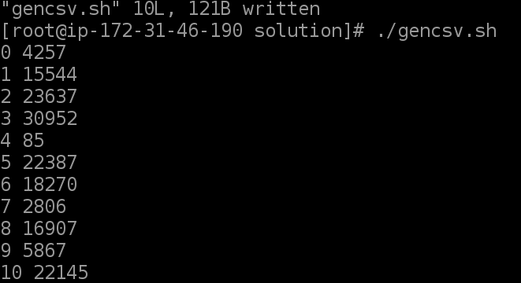

Run script to generate inputFile by command: ./gencsv.sh